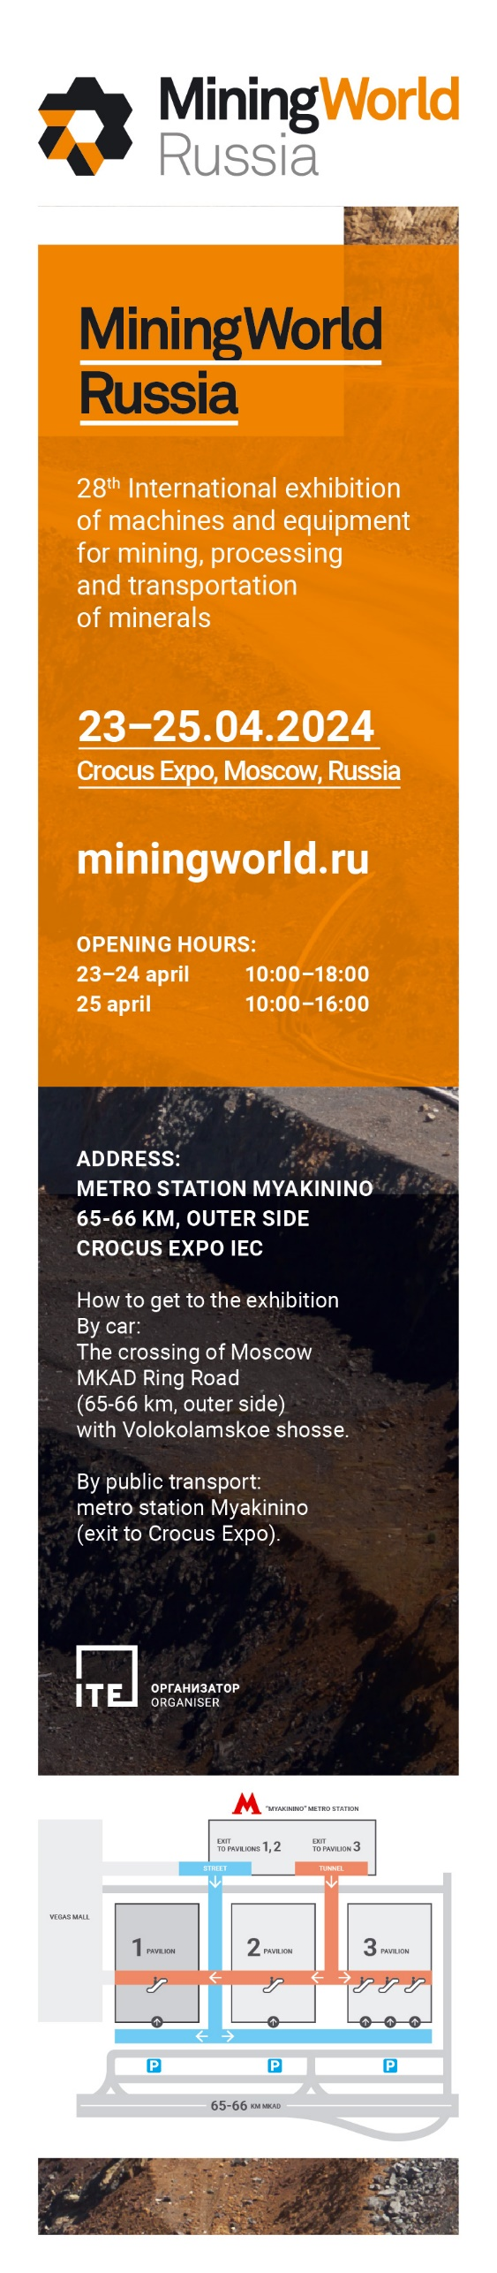

SAVE THE DATE

Dear colleague and partners,
Our company _____________ (company name) cordially invites you to visit our booth №________ at 28th International exhibition of machines and equipment for mining, processing and transportation of minerals – MiningWorld Russia.
The exhibition takes place April 23 – 25, 2024 in Russia, Moscow, Crocus Expo, Pavilion 1, Halls 1, 2, 3 and 4.
More than 27 years MiningWorld Russia gathers industry professionals under one roof, and _________ (company name) takes part in the exhibition for ___ time.
Get a free of charge ticket>>> using our company’s a unique promocode: _________ (promocode) and come to see machines and equipment we produce:

- Please indicate what kind of machines/equipment/technologies you are going to showcase at the exhibition.

Looking forward to meeting you at our booth №_______!

Please visit our website: _________________
Contact details: __________________________________________________

